The results of our research and completion for phase 4 led to our prototype for our application. When talking about the research, this includes preparing our own prototype for the application for the seniors to use and the feedback received given from fellow peers and researchers. All of the group members devised their own interpretation of what the application would look like, and from it we decided that there were certain aspects from each of them that we liked, and some that we did not like.

Some of the ideas that we did not like where thought to be more of a luxury rather than a necessity, as we wanted to get the main problem attended to. An example of what we deemed as unnecessary for the application was the ability for the buttons to enlarge (1). Another one was for the application to have more than one user, in case for multiple people interacting with the device (2). In addition, we also decided against a feature that has the user interact with a drag-and-drop event to a graph (3).

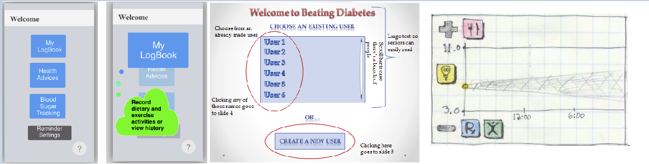

(1) (2) (3)

Of course the features listed above were not the only disagreeing ones, there were several more that came up in our discussion. Currently, we decided to not include multiple languages for simplicity sake, and we also voted against an idea of including a bar graph that stacks which corresponds to the user’s entries. Similarly, we decided to get rid of a prediction chart with events, as it can be misleading if predicting the wrong output.

Based on all of our collective research, we came to a conclusion of what the application should look like. There were many ideas that we thought were good and we made the best of all worlds by making a collaborated product.

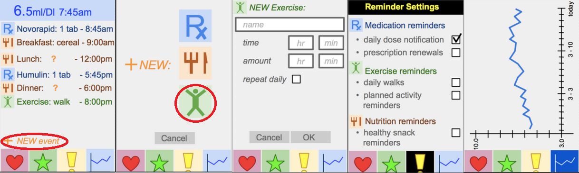

Based on the photos above, each screen has the “menu” bar at the bottom present, which allows for easy navigation through certain categories. Our home menu (first screen) has a layout of the day and a summary of the itinerary, as well as the last dosage of medicine at the header. Creating a new log is as easy as pressing the “+” and selecting an icon. Inputting the details will add it to the home screen, and it could be done with medicine, diet, or exercises. Reminders have their own category as it is important for people who have hard remembering events, and as an application we want it to be as helpful as possible. Lastly, an important implementation is the tracking of the blood sugar levels in the patient, and as the user enters the info, it will appear on the line graph tracking their levels and what time of the day it was recorded.

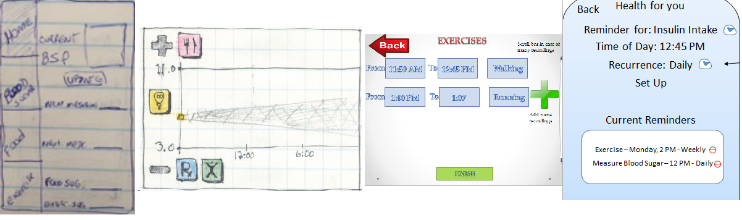

(1) (2) (3) (4)

Based on the prototype images shown, we extracted certain details. For example, from we took the idea of the home menu having a summary of the condition of the user based on the inputs (1). We took the simplified logos and used the blood sugar level graph to help navigate visually easier (2). The input of the logs are from (3) and the “+” sign was added to have the iconic “add more” events. Lastly, the reminders system was incorporated through simple notifications (4). After combining these, we refined the details and looks of it and made it more aesthetically pleasing, as well as simple and effective.

In short, the ideas of what we took and did not take can be summarized in a photo from a brainstorm session that we had as a group.

